**Team – 7**

Review 2:

**Project Title:**

**“Productivity Manager: Productivity Boosting through Tracking Activities.”**

**Team:**

|  |  |
| --- | --- |
| **Admin** | SABBIR AHMED KHAN |
| Admission No: 24SCSE1180755 |
| Email: [Sabbir.24scse1180755@galgotiasuniversity.ac.in](mailto:Sabbir.24scse1180755@galgotiasuniversity.ac.in) |
| Github ID: |
| **Member** | MITHUN CHANDRA ROY |
| Admission No: 24SCSE1180749 |
| Email: [raym23609@gmail.com](mailto:raym23609@gmail.com) |
| Github ID: |
| **Member** | MRITTIC ROY |
| Admission No: 24SCSE1180752 |
| Email: [rmridul481@gmail.com](mailto:rmridul481@gmail.com) |
| Github ID: |
| **Member** | SUSHMITA GOSH |
| Admission No: 24SCSE1180748 |
| Email: [anughossusmita94@gmail.com](mailto:anughossusmita94@gmail.com) |
| Github ID: |

**1. Project Description**

The Productivity Manager is a console-based Java application designed to help users manage, prioritize, and track their tasks. Users can add new tasks, assign priorities, and view the list of tasks in a structured format. It emphasizes core Java concepts such as object-oriented programming, file handling, and modular application design.

**2. Objective**

To build a user-friendly task tracking application using core Java without the use of databases. This system allows users to:  
- Add tasks with description, deadline, and priority  
- View all saved tasks  
- Automatically persist tasks to a file  
- Structure the application with DAO, model, and utility layers

**3. Technologies and Tools Used**

• Language: Java (JDK 17 or above)  
• IDE: IntelliJ IDEA  
• File Handling: Java I/O with `.txt` file storage  
• Architecture: Layered – Main, DAO, Model, UI, Utility

**4. Functional Requirements**

- Add new task  
- Validate task details (non-empty, valid date, priority range)  
- Display all existing tasks  
- Automatically load tasks from file on startup  
- Save tasks on exit or addition

**5. Project Structure:**

|  |  |  |
| --- | --- | --- |
| Package | Class Name | Purpose |
| model | Task, PriorityTask | Holds task data structure with optional priority |
| dao | TaskDAO, TaskFileDAO | Handles in-memory list and file operations |
| ui | ConsoleUI | Displays menu and handles user inputs |
| utils | TaskValidator | Utility functions for validation and formatting |
| main | MainApp | Application entry point with main loop |

**6. Sample File Format**

tasks.txt  
A simple text file that stores tasks line by line in a formatted representation like:  
  
Task ID: 1, Description: Finish report, Due: 2025-06-01, Priority: HIGH

**7. Known Issues**

- Input Mismatch Exceptions:  
 Using Scanner.nextInt() without validation may throw exceptions if non-numeric values are entered.  
  
Future Scope:  
- Use Scanner.hasNextInt() or try-catch for robust input handling.  
- Include task status (e.g., completed/incomplete)  
- Add support for editing and deleting tasks

**8. Screenshots**

**Adding task with date also the task has high/medium/low priority**

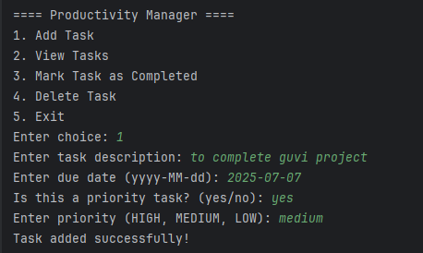

**Adding tasks**

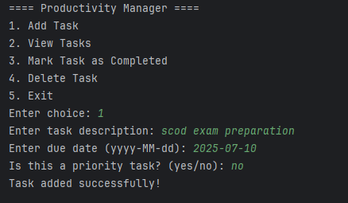

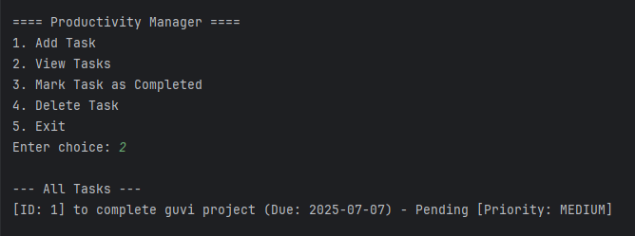

**Multiple tasks Added :**

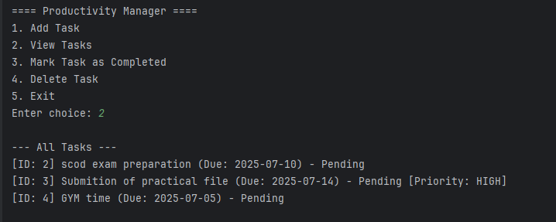

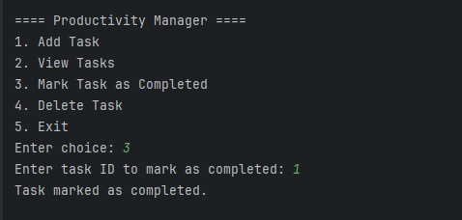

**If the task is completed it marked as completed. If it is not completed it shows as pending**

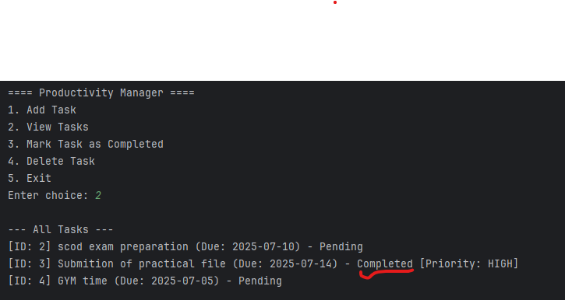

**We can delete the task if we want :**

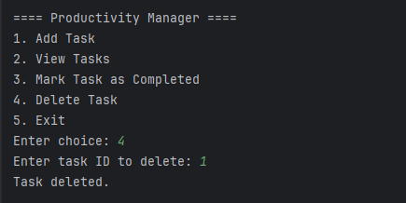

**9. Challenges Faced**

- Handling exceptions during input  
- Managing file format consistency  
- Ensuring unique task IDs  
- Providing a clean and intuitive console menu

**10. Conclusion**

This project reinforced skills in:  
- Java File I/O and OOP  
- Application structure using modular layers  
- User input handling and validation  
- Real-world logic implementation through console apps

- Problem solving with patience

**--- Thank You ---**